

Department of Computer Science and IT, Barani Institute of Management S` ciences, Rawalpindi Pakistan

Auction Abode

By

Hasnain Mahvia 22-ARID-487
Hafsa Saeed 22-ARID-483
Ali Mahmood 22-ARID-497
Zakria Aftab 22-ARID-533

Supervisor

Ms. Fakhar Un Nisa

Bachelor of Science in Computer Science (2022-2026)

DECLARATION

We hereby declare that this software, neither whole nor as a part has been copied out from any source. It is further declared that we have developed this software documentation and accompanied report entirely on the basis of our personal efforts. If any part of this project is proved to be copied out from any source or found to be reproduction of some other. We will stand by the consequences. No Portion of the work presented has been submitted of any application for any other degree or qualification of this or any other university or institute of learning.

Hasnain Mahiva Hafsa Saeed

Ali Mahmood Zakria Aftab

CERTIFICATE OF APPROVAL

It is to certify that the final year project of BS (CS) “Auction Abode” was developed by “Hasnain Mahvia, 22-Arid-487”, “Hafsa Saeed, 22-Arid-483”, “Ali Mahmood, 22- Arid-497”, “Zakria Aftab, 22-Arid-533”. under the supervision of “Ms. Fakhar Un Nisa” and that in their opinion; it is fully adequate, in scope and quality for the degree of Bachelors of Science in Computer Science.

---------------------------------------
Ms. Fakhar Un Nisa Supervisor

Executive Summary

The "Auction Abode: AI-Powered Real Estate Bidding Platform" is an innovative solution that redefines property auctions by integrating real-time bidding, artificial intelligence, and enhanced security measures. Addressing the challenges of accessibility, transparency, and fraud prevention in property transactions, the platform ensures a seamless and trustworthy auction experience for buyers, sellers, and administrators. Key features of the project include a real-time bidding system powered by Socket.io, ensuring instant bid updates for all participants. The AI-driven price suggestion engine leverages historical property data and market trends to recommend optimal bid prices, assisting users in making informed decisions. Additionally, automated property verification employs natural language processing (NLP) and fraud detection algorithms to authenticate documents and prevent fraudulent listings. The platform’s scalable and responsive architecture, built with React.js, Node.js, and MongoDB, ensures high performance and a smooth user experience even during peak auction activity. Geo-fenced auction notifications and personalized property subscriptions enhance user engagement by providing relevant alerts based on location and preferences. Secure authentication via JWT (JSON Web Tokens) and SSL encryption further strengthens platform security. With a focus on inclusivity, Auction Abode democratizes property investments by eliminating geographical barriers, enabling users from diverse backgrounds to participate in auctions effortlessly. Its compliance with property auction regulations ensures legal transparency and reliability, while its cloud-based infrastructure guarantees accessibility across devices. By combining real-time responsiveness, AI-driven insights, and robust security, Auction Abode aims to revolutionize the real estate auction landscape, fostering a more efficient, fair, and accessible property market for all.

Acknowledgement

All praise is to Almighty Allah who bestowed upon us a minute portion of His boundless knowledge by virtue of which we were able to accomplish this challenging task.
We are greatly indebted to our project supervisor “Ms. Fakhar Un Nisa” for personal supervision, advice, valuable guidance and completion of this project. We are deeply indebted to him for encouragement and continual help during this work.
And we are also thankful to our parents and family who have been a constant source of encouragement for us and brought us the values of honesty & hard work.

Hasnain Mahvia Hafsa Saeed

Ali Mahmood Zakria Aftab

Table of Contents

Chapter 1: Introduction 1
  - Brief 1
  - Relevance to Course Modules 2
  - Literature Review 4
  - Analysis from Literature Review 5
  - Methodology and Software Lifecycle for This Project 7
  - Rationale behind Selected Methodology 9
Chapter 2: Problem Definition 10
  - Problem Statement 11
  - Deliverables and Development Requirements 11
Chapter 3: Requirement Analysis 13
3.1 Functional Requirements 14
3.2 Non – Functional Requirements 16
3.3 Usability 17
3.4 Reliability 17
3.5 Performance 17
3.6 Supportability 17
3.7 Use case Model 17
3.8 Use Case Diagram 18
3.9 Actors Description 18
3.10 Use Case Description 18
Chapter 4: Design and Architecture 19
  - System Architecture 19
  - System Design 20
  - UML Behavioral Diagrams 20
  - Component Diagram 20
  - System Component Diagram 21
  - Package Diagram 21
  - Deployment Diagram 21
  - Activity Diagrams 22
  - State Machine Diagrams 23
  - UML Interaction-diagrams 24
  - Sequence Diagrams 25
  - Registration sequence Diagram 26
  - Login Sequence Diagram 27
  - User Activity Sequence Diagram 29
  - Node Structure 30
  - Communication Design Protocol 31
  - Class Diagram 32
Chapter 5: Implementation 33
  - Introduction to Implementation 33
  - System Development Environment 33
  - Backend Implementation 33
  - Frontend Implementation 34
  - Real-Time Bidding System 34
  - AI Modules 34
  - Price Suggestion Model 34
  - Data Base Integration 35
  - Security and Authentication 36
  - Deployment Overview 36
  - User Interface Screenshots 36
Chapter 6: Testing And Evaluation 43
  - Introduction to testing 43
  - Functional Testing 43
  - Unit Testing 44
  - Integration Testing 45
  - System Testing 45
  - Performance Testing 46
  - Security Testing 47
  - Useability Testing 47
  - Evaluation metrics 48
  - Limitations and Future Improvements 48
Chapter 7: Conclusion And Future Work 49
7.1 Conclusion 49
7.2 Future Work 49

List of Figures
Fig 3.1: Use Case diagram 15
Fig 4.1: System Architecture 17
Fig 4.2: Component Diagram 19
Fig 4.3: System Component Diagram 19
Fig 4.4: Package Diagram 20
Fig 4.5: Deployment Diagram 21
Fig 4.6: Activity Diagram 22
Fig 4.7: State Machine Diagram 24
Fig 4.8: Register Sequence Diagram 25
Fig 4.9: Login sequence diagram 26
Fig 4.10: User Sequence Diagram 27
Fig 4.11: Node Structure Diagram 29
Fig 4.12: Communication Design Protocol 29
Fig 5.1: Component Diagram 37

Fig 5.2: Abouts Diagram 37

Fig 5.3: login Diagram 38

Fig 5.4: Register Diagram 39

Fig 5.6: Property Management Diagram 40

Fig 5.7: User Management Diagram 40

Fig 5.8: Admin Dashboard Diagram 41

Fig 5.9: Add Property Diagram 42

Fig 5.10: Home Diagram 42

Chapter 1: Introduction

This chapter introduces "Auction Abode," an AI-powered real estate bidding platform designed to transform the property auction landscape by integrating real-time bidding, artificial intelligence, and enhanced security mechanisms. The project aims to address critical challenges in traditional property auctions, including limited accessibility, lack of transparency, fraud risks, and inefficient bidding processes.
By leveraging cutting-edge technologies such as WebSocket’s, AI-driven price prediction, and automated property verification, Auction Abode ensures a seamless, fair, and secure bidding experience for buyers and sellers alike. The platform provides instant bid updates, intelligent price recommendations, and fraud detection mechanisms to safeguard users from deceptive practices.

Brief
Studies and market analyses consistently highlight the transformative potential of AI and real- time technologies in revolutionizing digital property auctions. Traditional real estate bidding systems face challenges such as bid transparency issues, fraudulent listings, scalability limitations, and inefficient user experiences. Auction Abode leverages AI-powered price prediction, real-time bidding mechanisms, and automated property verification to enhance fairness, accessibility, and security in real estate transactions.
By integrating machine learning models, the platform analyzes historical auction data to provide accurate property price recommendations, allowing buyers to make informed decisions. Additionally, automated fraud detection mechanisms use NLP and pattern
recognition algorithms to validate property documents, mitigating risks of misinformation and fraudulent listings. These advancements ensure that the auction process remains fair, efficient, and data-driven. In response to the growing demand for intelligent and scalable real estate platforms, Auction Abode incorporates real-time bid synchronization via WebSocket’s, ensuring that all participants receive instant updates without delays.

The platform’s cloud-based infrastructure supports seamless scalability, accommodating high user traffic without performance degradation. Geofencing and subscription-based auction notifications further enhance user engagement, ensuring buyers receive relevant property alerts based on their preferences and location.
To ensure efficient and adaptive development, the project adopts the Agile methodology, allowing for continuous refinements, user feedback integration, and iterative improvements. This approach ensures that Auction Abode evolves dynamically, meeting the evolving needs of buyers, sellers, and regulatory frameworks, while positioning itself as a pioneering AI- driven solution in the real estate auction industry.

Relevance to Course Modules
- Web Development guided us in creating a dynamic and responsive user interface for the Auction Abode platform, ensuring seamless accessibility across devices and an intuitive bidding experience.
- Object-Oriented Analysis and Design equipped us with the skills to design comprehensive system workflows through use cases, activity diagrams, and sequence diagrams, effectively modeling the bidding process, user interactions, and auction management functionalities.
- Database Administration enabled us to design and manage the MongoDB database, securely storing property listings, bid histories, user profiles, and transaction records, ensuring data integrity and efficient retrieval.
- Artificial Intelligence was a core course that laid the foundation for developing the AI- powered price prediction model and fraud detection algorithms, which enhance bid accuracy, property verification, and overall auction security.

Project Background

The project "Auction Abode: AI-Powered Real Estate Bidding Platform" addresses critical challenges in the property auction industry by leveraging artificial intelligence and real-time technologies to enhance transparency, efficiency, and security in real estate transactions. Traditional property auctions often suffer from limited accessibility, bid manipulation, fraud risks, and inefficient bidding mechanisms, leading to a lack of trust and engagement from buyers and sellers. This project bridges these gaps by developing an intelligent, automated auction system powered by real-time WebSocket communication and AI-driven pricing models.

The platform enables real-time bidding synchronization, ensuring that all participants receive instant bid updates without delays. By employing machine learning and predictive analytics, Auction Abode provides intelligent price recommendations based on historical auction data and market trends, helping users make data-driven bidding decisions. Furthermore, automated fraud detection mechanisms, incorporating natural language processing (NLP) and AI- powered verification, safeguard users against deceptive property listings and tampered auction data.
A key strength of this project is its interdisciplinary approach, bringing together expertise from real estate professionals, data scientists, and web developers. This collaboration ensures that the AI models and bidding mechanisms are both technically advanced and practically relevant. Additionally, the platform adheres to strict security standards, integrating JWT authentication, SSL encryption, and compliance with property auction regulations, ensuring a safe and trustworthy bidding environment.
In summary, Auction Abode represents a groundbreaking advancement in the real estate auction industry, offering a transparent, AI-driven, and highly efficient alternative to traditional property bidding systems. By combining real-time responsiveness, AI-powered insights, and robust security measures, the platform sets a new standard for accessible and reliable real estate transactions, empowering a diverse range of buyers and sellers across global markets.

Literature Review

Integration of Artificial Intelligence and Real-Time Technologies in Property Auctions

The integration of artificial intelligence (AI) and real-time web technologies in property auctions has revolutionized how real estate transactions are conducted. These innovations have introduced new levels of security, transparency, efficiency, and scalability, enabling smarter, faster, and fairer bidding processes. Below is an overview of significant studies that demonstrate the advancements in this evolving field:

AI-Powered Price Prediction in Real Estate Auctions

This study explored various machine learning models such as regression analysis and deep neural networks to predict property auction prices based on historical datasets. The research concluded that AI-based pricing models significantly improve bid accuracy, align with seller expectations, and promote fair market valuations by minimizing human error in appraisals.

Real-Time Bidding Systems Using WebSockets
This research investigated the implementation of WebSocket technology to achieve real- time auction synchronization. Key findings included instant bid updates, reduced latency, and prevention of last-minute manipulation. The study demonstrated the scalability and responsiveness of WebSockets in managing large-scale, high-traffic property auctions.

AI-Driven Fraud Detection in Online Marketplaces

Focusing on fraud prevention, this study employed Natural Language Processing (NLP) and anomaly detection algorithms to identify fake property listings, forged documents, and suspicious bidding behaviors. The use of AI tools helped enhance platform trust, reduce financial risk, and ensure the integrity of digital property auctions.

Cloud-Based Auction Platforms for Scalability and Accessibility

This research highlighted the benefits of cloud computing in online auction platforms, including efficient handling of large transaction volumes, improved uptime and bid processing speeds, and accessibility across regions and devices. Cloud-based systems support the globalization and inclusivity of real estate auctions by offering robust and scalable infrastructure.

User Experience and UI Design in Digital Auctions

The study emphasized the importance of user interface (UI) and user experience (UX) in enhancing bidder engagement. By analyzing platforms built with responsive frameworks like React.js, the research showed how intuitive design improves usability for both novice and expert users, reduces friction in the bidding process, and boosts participation rates. Good UI/UX is key to building trust and ease-of-use in digital auction environments.

Comparing Traditional vs. AI-Enhanced Property Auctions

This comparative study evaluated conventional real estate auctions against AI-powered digital platforms. Key outcomes included reduced fraud incidents, higher accuracy in property valuation, and increased bidder turnout. AI-enhanced systems also automate document verification and ensure legal compliance, thereby expediting property transactions and minimizing human error.

Analysis from Literature Review

our analysis learning models for price prediction, WebSocket’s for real-time bidding synchronization, and AI-driven fraud detection in enhancing the transparency and efficiency of auction platforms. Similarly, our project reinforces the importance of instant bid updates, AI-powered price estimation, and robust security measures in fostering trust among users.
Additionally, our work highlights the critical role of cloud-based architecture in ensuring scalability and accessibility, echoing recommendations from prior studies on deploying real- time auction platforms. Furthermore, Auction Abode extends these findings by incorporating
reveals a strong alignment with existing findings regarding the transformative potential of AI and real-time technologies in digital property auctions. The literature underscores the effectiveness of machine
AI-powered verification mechanisms, which automate document authentication and fraud detection, significantly improving trust and security in real estate transactions.
Our project also contributes novel insights by integrating a data-driven, AI-enhanced bidding system tailored specifically for large-scale property auctions. This approach not only improves bid accuracy and transaction efficiency but also addresses challenges such as real-time scalability, bid manipulation prevention, and market fairness. By building upon the advancements and gaps identified in existing research, Auction Abode establishes itself as an innovative, AI-driven solution poised to revolutionize digital real estate auctions.

Table 1.1: Literature Review

Title | Machine Learning Methods  and Findings | Shortcomings and Pitfalls
AI-Powered Price Prediction in Real Estate Auctions | Regression models and neural networks analyzed historical auction data, achieving high  accuracy in price estimation. | Struggled with market volatility, requiring frequent retraining to remain relevant.
Real-Time Bidding  Systems Using WebSockets | WebSocket technology ensured instant bid updates and prevented delayed transactions in digital  auctions. | High server load during peak bidding events led to latency issues.
AI-Driven Fraud Detection in Online Marketplaces | NLP and anomaly detection identified fraudulent property listings and suspicious bidding  behaviors. | False positives were a challenge, leading to legitimate listings being  flagged incorrectly.
Cloud-Based Auction  Platforms for  Scalability and Accessibility | Cloud computing enabled seamless auction transactions and bidder participation from any  location. | Security vulnerabilities in cloud storage required stronger encryption and  access controls.
User Experience and  UI Design in Digital  Auctions | Intuitive UI/UX designs  improved user engagement and  bid participation. | Some platforms lacked  accessibility features,  limiting usability for non- tech-savvy users.
Continuous Learning in AI-Enhanced Auctions | Feedback loops enabled AI models to refine pricing predictions and detect emerging  fraud trends. | Data privacy concerns arose in using bidder behavior data for continuous model  training.

  - Methodology and Software Lifecycle for This Project

We are adopting the Agile methodology for the development of Auction Abode. This approach aligns with the project's dynamic nature and the need for continuous improvements based on stakeholder feedback. Agile allows the team to manage development through iterative phases, ensuring timely and incremental delivery of functional components.
Face-to-face communication and ongoing stakeholder engagement are central to this methodology, fostering collaboration and adaptability at every stage. The iterative nature of Agile promotes sustainable development and enables the team to respond efficiently to evolving requirements.

Agile Process for Auction Abode:

    - Requirements Elicitation: Identifying and analyzing stakeholder needs to define clear project goals.
    - Design Requirements: Converting stakeholder needs into technical specifications and system models.
    - Construction/Iteration: Developing functional increments of the platform with frequent coding and testing cycles.
    - Testing/Quality Assurance: Ensuring each increment meets performance and security standards through rigorous testing.
    - Deployment: Delivering usable software increments to stakeholders at regular intervals.
    - Feedback: Collecting user and stakeholder input to refine and enhance the platform

Key Ideas and Guidelines of Agile Methodology
- Iterative Development
Agile divides the project into manageable iterations called sprints, typically lasting two to four weeks. Each sprint delivers a functional increment, ensuring continuous progress and the integration of early feedback.

Cross-Functional Team
The development team is composed of skilled professionals in AI, web development, database management, and security. This structure encourages seamless collaboration and allows the team to adapt quickly to changing requirements.

Product Backlog
A product backlog is a prioritized list of tasks, features, and user stories maintained by the product owner. It serves as the central source of work items and requirements for the development team.

User Stories
User stories are short, user-focused descriptions of desired functionality. They help the team stay aligned with user needs and ensure the development process remains value-driven and efficient.

Continuous Integration and Delivery
New code is integrated and deployed frequently, allowing early detection of issues. This practice ensures a stable development process, reduces risk, and accelerates product delivery.

Retrospectives
At the end of each sprint, the team conducts retrospectives to review their performance, identify areas of improvement, and implement necessary changes in the next sprint.

Agile Roles in Auction Abode Development

  - Product Owner: Defines and prioritizes platform features based on stakeholder needs and real estate market trends.
  - Agile Master: Ensures adherence to Agile principles, facilitates communication, and resolves development challenges.
  - Development Team: A cross-functional team responsible for designing, implementing, and testing high-quality, functional components of Auction Abode.

The flexibility and iterative nature of Agile make it an ideal choice for developing a complex, scalable, and user-focused project like Auction Abode, ensuring alignment with stakeholder expectations and delivering value at every stage.

Rationale behind Selected Methodology

The Agile methodology was selected for the development of Auction Abode due to the
following reasons:

  - Easily and Quickly Adapt to Change
Agile enables the team to accommodate changing requirements and stakeholder feedback efficiently. This flexibility is crucial for a dynamic project like Auction Abode, where market trends and user needs can evolve rapidly.

  - User-Focused Testing
With continuous feedback loops and iterative development, the platform is consistently tested and refined to ensure optimal functionality for buyers, sellers, and auction administrators.

  - Better Project Control
Regular sprint reviews and retrospectives provide transparency into project progress. This approach helps identify issues early and allows for timely adjustments, ensuring a smoother development process.

  - Creativity and Innovation
Agile encourages a collaborative and adaptive environment where the team can implement innovative features such as real-time bidding synchronization, AI-powered price prediction, and intelligent fraud detection mechanisms.

  - Reduces Technical Debt
Through continuous integration and prompt bug fixing, Agile helps prevent the buildup of unresolved issues, leading to a stable and maintainable platform over time.

  - Improved Quality
Frequent iterations and strong quality assurance practices result in a reliable, secure, and efficient platform that meets high standards in usability, performance, and security.

Chapter 2: Problem Definition

In this chapter, we will discuss the challenges that the project, "Auction Abode: AI-Powered Real Estate Bidding Platform," aims to address. The primary problem lies in the limitations of traditional real estate auction systems, which often suffer from inefficiencies, lack of transparency, and security vulnerabilities.
Traditional auction platforms frequently fail to provide real-time bid updates, leading to delays, bid manipulation, and an unfair bidding environment. Additionally, fraudulent property listings, lack of AI-driven price validation, and outdated verification processes create risks for both buyers and sellers. These issues undermine trust in online real estate transactions, discouraging broader market participation. Another critical challenge is scalability—existing platforms struggle to handle high traffic during peak auction times, causing performance issues, bid lags, and system crashes. Furthermore, many platforms lack intelligent user engagement features, such as personalized property recommendations and geofencing-based notifications, reducing auction participation and efficiency.
This chapter will also outline the desired outcomes of the project, which focus on developing a secure, AI-driven auction system that provides real-time bid synchronization, fraud detection, and intelligent price recommendations. By addressing gaps in transparency, speed, and security, Auction Abode aims to empower buyers, sellers, and administrators with a trustworthy and efficient auction experience, ultimately optimizing real estate transactions. Through an examination of existing challenges in property auctions and the limitations of conventional bidding platforms, this chapter lays the foundation for a comprehensive exploration of the problem domain and the transformative potential of AI-driven auction solutions.

- Problem Statement

Efficient and transparent property auctions are essential for fair market competition and seamless real estate transactions. However, traditional auction systems suffer from bid manipulation, delayed updates, security vulnerabilities, and fraud risks, leading to a lack of trust and efficiency. These challenges are further exacerbated by high user traffic, scalability issues, and outdated verification processes, which hinder smooth and reliable auction experiences.

To address these limitations, the primary goal of this project is to develop an AI-powered real estate auction platform that ensures real-time bidding synchronization, intelligent price prediction, and automated fraud detection. This system leverages cutting-edge AI models and real-time WebSocket communication to create a secure, transparent, and scalable bidding environment. By overcoming the inefficiencies of conventional methods, Auction Abode aims to revolutionize the real estate auction process, providing users with a fast, reliable, and fraud- resistant platform.
The expected outcome is a streamlined, technology-driven auction process that enhances bid accuracy, prevents fraudulent transactions, and ensures fair market participation. By implementing personalized user engagement features, such as geofencing-based notifications and AI-driven property recommendations, the platform aims to increase accessibility and boost user confidence in online real estate transactions. Through this innovation, Auction Abode aspires to set a new industry benchmark for secure, intelligent, and real-time digital auctions, transforming the way properties are bought and sold in the modern era.

Deliverables and Development Requirements

Deliverables
In the context of our project, "Auction Abode: AI-Powered Real Estate Bidding Platform," deliverables represent the tangible outcomes expected upon project completion or at specific phases. These deliverables serve as measurable indicators of progress, guiding the project toward its objectives.
Potential deliverables for this project include:

- Real-Time Bidding System
Develop and deploy a real-time WebSocket-based auction system, ensuring instant bid updates and transparency for all users.

- AI-Powered Price Prediction Model
Implement machine learning algorithms to analyze market trends and provide data-driven price recommendations for properties.

- Fraud Detection Mechanism
Integrate AI-based document verification and anomaly detection to prevent fraudulent property listings and bid manipulations.

- Cloud-Based Auction Platform
Deliver a scalable, web-based auction system accessible to buyers, sellers, and administrators from any location.

- User Interface Design
Create a responsive, intuitive UI tailored to different user roles, ensuring smooth
navigation and user-friendly auction management.

- Secure Database Infrastructure
Develop a MongoDB-based database system to store property details, user profiles, and bidding history, ensuring data integrity and security.

- Testing and Validation Reports
Provide detailed reports on system performance, security, and AI model accuracy,
ensuring reliability and compliance.

- User Support Resources
Develop comprehensive documentation, FAQs, and tutorials to assist users in understanding the auction process and platform features.

By delivering these key components, Auction Abode aims to enhance efficiency, security, and trust in online real estate auctions, fostering a seamless and fair bidding experience.

- Development Requirements

The development requirements outline the technical specifications and constraints that "Auction Abode" must meet to ensure an effective and reliable real estate auction platform. These requirements serve as the foundation for system design and implementation.

Development requirements include:

- Real-Time Performance
Implement WebSocket’s to support instantaneous bid updates, ensuring high-speed, scalable bid processing.

- Scalability and Reliability
Design the system to handle high traffic volumes and multiple concurrent users, ensuring fast and stable performance during peak auction times.

- Data Security and Privacy
Utilize JWT authentication, SSL encryption, and access controls to safeguard user and transaction data against cyber threats.

- Fraud Prevention
Develop AI-powered verification mechanisms to automatically validate property documents, minimizing fraudulent listings and unauthorized transactions.

- Intuitive User Experience
Ensure the UI/UX is simple, responsive, and accessible, making auction participation easy for buyers, sellers, and administrators.

- Automated Auction Notification
Implement geofencing-based alerts and personalized notifications, keeping users informed about relevant auctions

- Regulatory Compliance
Ensure adherence to property transaction laws and ethical standards to maintain a legally compliant and trustworthy auction platform.

By meeting these technical and functional requirements, Auction Abode guarantees a secure, scalable, and efficient online property auction experience, transforming the real estate bidding landscape with AI-driven automation and real-time transparency.

Chapter 3: Requirement Analysis

This chapter delves into the comprehensive analysis of requirements for the project, "Auction Abode: AI-Powered Real Estate Bidding Platform." Central to this analysis is the Software Requirements Specification (SRS) document, which serves as the foundation for defining the essential functionalities, features, and technical specifications required for the platform’s successful development and implementation. By detailing the project scope, user needs, and system constraints, the SRS provides a structured roadmap for all subsequent phases of the project.
The chapter highlights the importance of requirement gathering in shaping the project’s direction. Through detailed analysis and continuous stakeholder engagement, the project team ensures a clear understanding of user expectations, market demands, and security concerns. This systematic approach facilitates the identification of key use cases that form the basis of system development.

Key components of the requirement analysis include:

  - Functional Requirements: Defining core system capabilities such as real-time bidding, AI-powered price prediction, fraud detection, and secure transaction management.
  - Non-Functional Requirements: Addressing performance metrics, including system reliability, scalability, low-latency bid processing, and compliance with data security standards.
  - User Requirements: Understanding the specific needs of buyers, sellers, and administrators, ensuring the system is intuitive, accessible, and efficient.

By thoroughly analyzing these requirements, the project lays a solid foundation for designing and implementing a robust, secure, and user-friendly real estate auction platform, aligned with both technical and business objectives.

Functional Requirements

The Auction Abode system must provide the following functionalities and features to meet user needs and project objectives:

Data Collection and Analysis

  - Data Collection: The system will collect and store property listings, bidding histories, user profiles, and real estate market trends.
  - Data Analysis: AI-powered models will analyze historical bidding data to predict property prices, detect fraudulent activities, and enhance auction strategies.

Property Listing and Management

  - User-Friendly Interface: Sellers will access an intuitive dashboard to list properties, manage auction details, and track bidding activity.
  - Validation and Storage: Uploaded property documents will be validated using AI- based fraud detection. All auction data will be securely stored using a MongoDB database.

User Registration and Authentication
  - Registration: Buyers, sellers, and administrators can register to use the platform.
  - Authentication: JWT-based login and two-factor authentication (2FA) will ensure secure access and participation.

User Interface (UI)
  - Design Features:
    - A modern, responsive, and easy-to-navigate interface will be used.
    - Real-time dashboards will show live bidding and pricing trends.

Feedback and Information Input

  - Users can submit property descriptions, legal documents, and details via interactive forms.
  - Feedback tools will allow users to rate auction experiences and report suspicious activity.

AI-Powered Bidding and Pricing Models
  - AI will offer real-time price predictions to help sellers set competitive starting prices.
  - The system will monitor and flag irregular bidding patterns indicating potential fraud.

User Feedback and Interaction

  - Buyers and sellers can share feedback on pricing, auction fairness, and platform
usability.
  - Machine learning will use this feedback to refine future price predictions.

Admin Functionality

  - Administrators will manage user accounts, approve listings, and maintain platform
security.
  - Admins can also track system performance, modify auction rules, and ensure legal compliance.

Notification System
  - Real-time alerts will be sent for:
    - New listings in selected categories.
    - Bid updates and auction status changes.
    - Fraud detection or security warnings.

Progress Tracking and Reporting
  - Sellers can monitor auction performance. Buyers can view their bidding history.
  - The system will generate detailed reports on activity, trends, and security events for stakeholders.

Non-Functional Requirements

These non-functional requirements ensure the overall efficiency, performance, and
compliance of the Auction Abode platform.

Usability

The platform must provide a user-friendly interface for all roles (buyers, sellers, admins).

Navigation must be clear, with tooltips, step-by-step workflows, and guided instructions.

Reliability

The system must maintain high availability with minimal downtime.

Auction tracking, bid processing, and transactions must happen in real time.

Performance

The system must support large numbers of concurrent users and auctions.
      - Bid updates must be processed within milliseconds for real-time accuracy.

Supportability
      - Built-in error handling and recovery options must assist users during issues.
      - Help resources like FAQs, tutorials, and live support should be available.

Design Constraints
      - The system must comply with relevant legal and financial regulations.
      - It should be scalable and modular for future upgrades without major redesign.

Licensing Requirements

      - All third-party tools, APIs, and cloud services used must have valid licenses, properly documented and maintained.

Data Privacy and Security
      - User data must be encrypted (AES-256) both in transit and at rest.
      - Role-Based Access Control (RBAC) must be implemented to prevent unauthorized access to sensitive information.

These requirements are essential for building a secure, stable, and legally compliant auction platform that delivers long-term value and user trust.
- A description of system actors (e.g., buyer, seller, admin)
- A detailed description of each use case such as login, bid placement, property listing, and feedback submission.

- Use Case Diagram

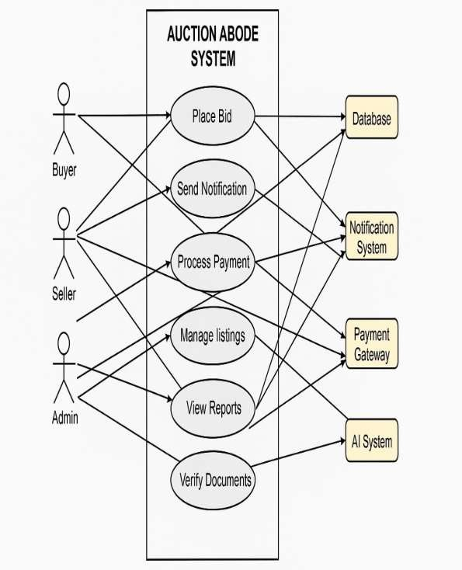

Diagram Explanation:

  - Actors: Represent different users (Buyers, Sellers, Admin).
  - Use Cases: Represent functionalities like User Registration, Property Listing, Real-
Time Bidding, AI Verification, Notifications, Payment, and Bidder Reallocation.

Relationships:
    - Direct interaction (solid lines) between users and system functionalities.
    - System actions (dashed lines) where the system processes data automatically.

3.3.2 Actors Description

Actor | Role | Responsibilities
Buyer | Participates in auctions. | - Searches for properties  - Places bids in real time  - Receives notifications  - Completes payments
Seller | Lists properties for sale. | - Adds property details  - Monitors auctions  - Manages listings
Admin | Manages the system. | - Oversees transactions  - Verifies property authenticity  - Handles disputes

3.3.3 Use Case Description

Each use case represents an interaction between an actor and the system.

Use Case  Name | Actors | Preconditions | Flow of Events | Postconditions
User Registration & Login | Buyer, Seller, Admin | User must have valid email/credentials. | - User enters details.  - System verifies credentials.  - User logs in. | User can access the system.
Property  Listing | Seller | Seller must be  logged in. | - Seller uploads  property details.  - System verifies  and saves the listing. | Property is listed  for auction.
Real-Time Bidding | Buyer, Seller, System | User must be logged in, and auction must be active. | - Buyer places a bid.  - Bid updates in real time.  - Highest bid is  displayed. | Auction updates with the latest bid.
AI  Verification | System | Property documents must be uploaded. | - System scans documents.  - AI checks for  fraud.  - Status is updated. | Property verification is completed.
Notifications & Alerts | Buyer, Seller | User must be subscribed to an auction. | - System detects an event (bid placed, auction  start, payment | User receives an update.

due).
2. Sends a notification.
Payment Processing | Buyer, System | Auction must be completed. | - Buyer selects a payment method.  - Payment is  processed securely. | Transaction is completed.
Bidder Reallocation | System, Buyer | Original winner withdraws. | - System selects the next highest bidder.  - Sends a confirmation. | The property is reassigned.

Chapter 4: Design and Architecture

This chapter explores the design and architecture of the "Auction Abode " system, emphasizing key principles and decisions vital for project success. It outlines the significance of thoughtful design considerations in meeting project objectives efficiently. From conceptualizing system structure to detailing architectural components, it serves as a blueprint for translating requirements into a functional solution. Providing insights into the project's technical foundation, it fosters a deeper understanding of the design process.

System Architecture

The Auction Abode system follows a three-tier architecture consisting of front-end, back-end, and database layers, ensuring scalability, efficiency, and real-time performance. The front- end (React.js) manages the user interface with a responsive design, allowing users to browse properties, place bids, and receive real-time updates via WebSocket’s (Socket.io). Redux handles state management for smooth data flow. The back-end (Node.js, Express.js) acts as the API gateway, handling authentication (JWT), auction logic, AI-based property verification, and payment processing. It also integrates with a notification service for real- time alerts. The database layer (MongoDB) stores users, properties, bids, and transactions, supporting high-speed queries and real-time updates for efficient auction management. This three-tier structure ensures a secure, scalable, and high-performance platform for real-time property bidding.

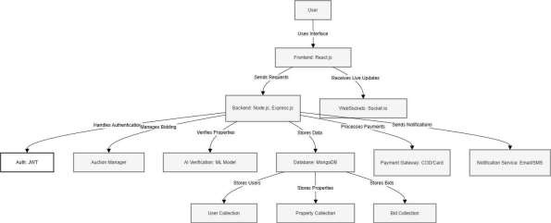

Fig 4.1: System Architecture

  - System Design
The Auction Abode system follows a modular, scalable, and efficient architecture, ensuring seamless user interactions, business logic, and data management. The user interface, built with React.js, provides a responsive and interactive experience, allowing users to browse properties, place bids, and manage their accounts. State management with Redux ensures smooth data handling, while WebSocket’s (Socket.io) enable real-time bid updates. The backend API, developed using Node.js and Express.js, acts as the API gateway, managing authentication (JWT), bidding logic, AI-based property verification, and transaction processing. It also integrates with external services like payment gateways (Stripe, PayPal) for secure transactions and notification services (Email/SMS) for real-time alerts. The database layer, powered by MongoDB, efficiently stores users, properties, bids, and transactions, ensuring fast queries and real-time synchronization. This structured design guarantees a high-performance, secure, and real-time property auction experience.

UML Behavioral Diagrams

UML (Unified Modeling Language) behavioral diagrams provide a visual representation of the system’s structure and interactions. These diagrams illustrate the dynamic aspects of the system, focusing on how components and actors interact during operation.

Component Diagram:
This diagram illustrates the system's components and their interactions, offering a visual representation of the system's architecture. It showcases how various components collaborate to achieve system functionality and highlights dependencies between them.

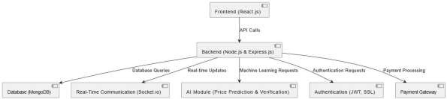

Fig 4.2: Component Diagram

System Component Diagram:

The system component diagram visually represents the high-level architecture of the "Auction Abode" system, illustrating the key components and their interactions. It provides a clear overview of how different modules and subsystems within the system are organized and interconnected to achieve the desired functionality.

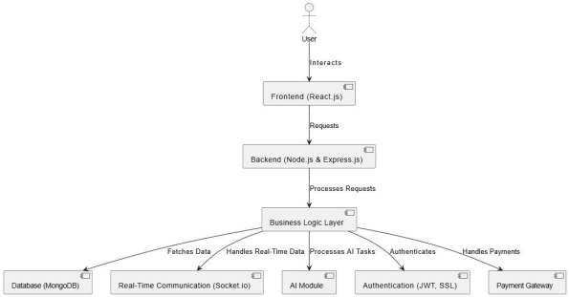

Fig 4.3: System Component Diagram

Package Diagram:
The Package Diagram organizes the components of the "Auction Abode" system into logical groupings or packages, illustrating the modular structure of the system. It provides an overview of the system’s dependencies and relationships, aiding in better understanding and management of system complexity.

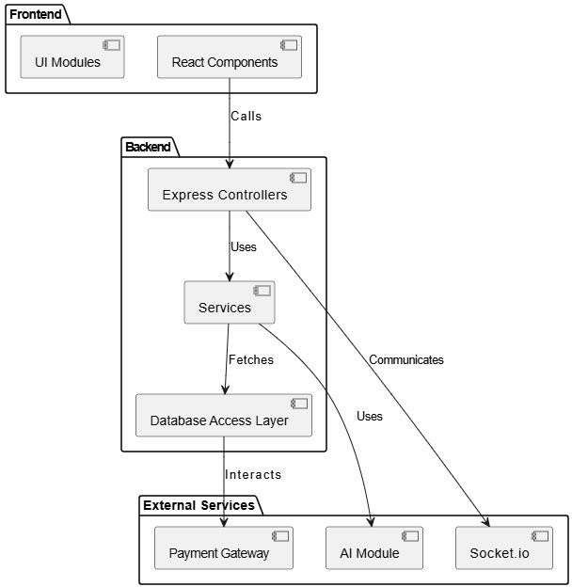

Fig 4.4: Package Diagram

Deployment Diagram:
The Deployment Diagram illustrates the physical deployment of the "Auction Abode" system across various hardware nodes. It provides a detailed view of how the system's software components are distributed and interconnected within the network infrastructure.

This diagram ensures clarity in understanding the system's deployment architecture, facilitating effective deployment and management.

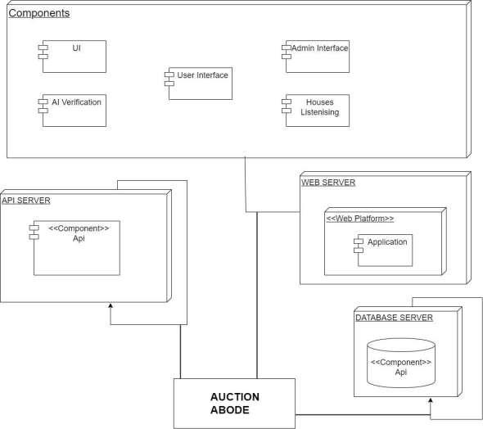

Fig 4.5: Deployment Diagram

- UML Behavioral Diagrams

UML Behavioral Diagrams provide a visual representation of the dynamic behavior of the
"Auction Abode" system. These diagrams illustrate interactions among system components,

entities, and users, showcasing how tasks are accomplished and processes flow within the system.

Behavioral diagrams offer insights into functionality, message passing, and state transitions,
aiding in efficient system design and effective communication with stakeholders.

Activity Diagrams:
The flow of activities within a system, illustrating the sequence of actions or steps required to accomplish a specific task or behavior.

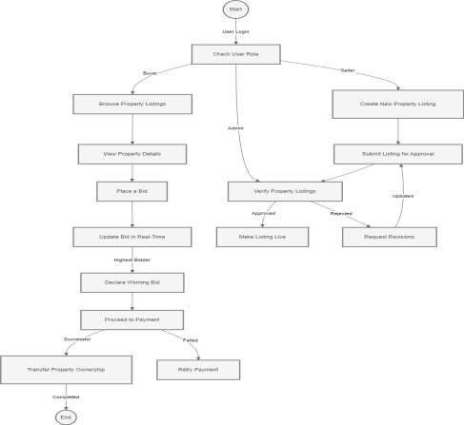

Fig 4.6: Activity Diagram

- State Machine Diagrams:
This diagram models the behavior of individual components or objects within the system, depicting their states and transitions between them. It offers a visual representation of how the system responds to events and stimuli, guiding the understanding of its dynamic behavior.
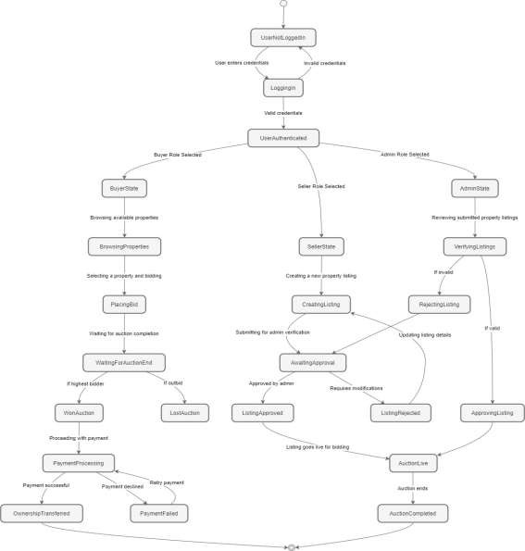

Fig 4.7: State Machine Diagram

- UML Interaction-diagrams
UML Interaction Diagrams illustrate dynamic system behavior, emphasizing object
interactions during runtime. Sequence Diagrams, showing message flow chronologically.

Sequence Diagrams
Sequence diagrams in UML illustrate the interactions between objects or components in a system over time, depicting the flow of messages between them.

- Registration sequence Diagram

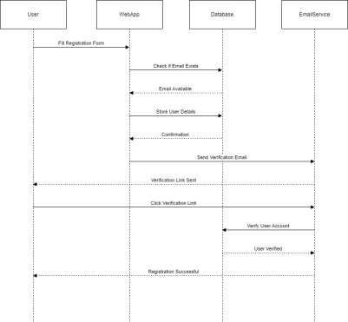

Fig 4.8: Register Sequence Diagram

- Login Sequence Diagram

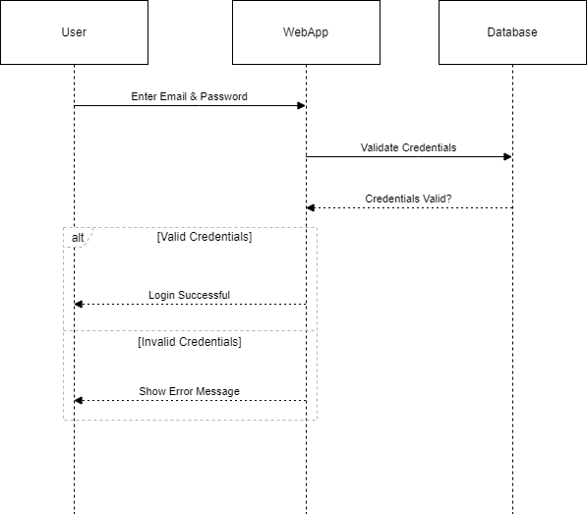

Fig 4.9: Login sequence diagram

- User Activity Sequence Diagram

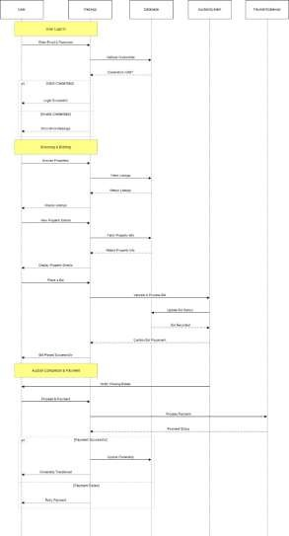
Fig 4.10: User Sequence Diagram

- Node Structure

Node structure refers to the arrangement and organization of nodes within a network or hierarchical system, defining their relationships and connectivity. It establishes the framework for data transmission, processing, and communication across the network.

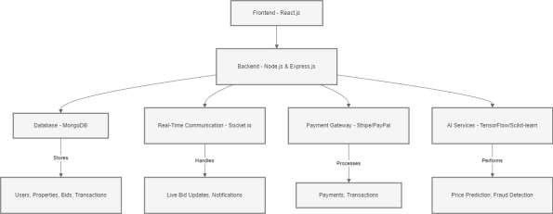

Fig 4.11: Node Structure Diagram

- Communication Design Protocol

Communication Design Protocol is the exchanging of information. It defines protocols, formats, and procedures to ensure seamless communication within the system architecture.

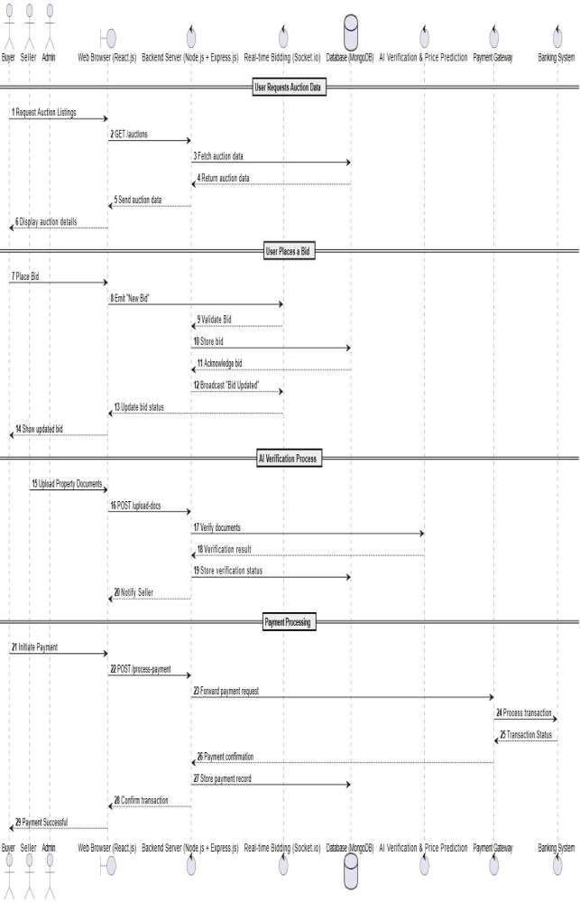

Fig 4.12: Communication Design Protocol

- Class Diagram

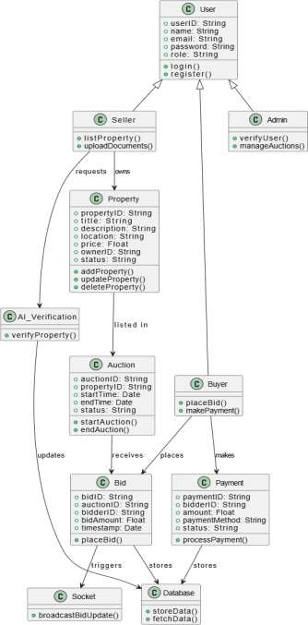

Fig 4.13: Class Diagram

Chapter 5: Implementation

Introduction to Implementation

The implementation phase marks the translation of design specifications into a working system. Auction Abode is built as a full-stack web application with AI capabilities. The focus is on real-time auctions, secure authentication, intelligent pricing suggestions, and fraud prevention via document verification. Implementation was carried out incrementally, ensuring functional units were developed, tested, and integrated smoothly.

System Development Environment

Auction Abode was developed using modern web and AI tools:

    - Frontend: React.js for responsive UI
    - Backend: Node.js with Express.js for routing and API handling
    - Database: MongoDB (NoSQL)
    - AI: Python with Scikit-learn, Tesseract OCR, and spaCy
    - Real-Time Engine: Socket.io for bid updates
    - Security: JWT for authentication, Bcrypt for password hashing, SSL for encryption
    - Deployment Tools: Netlify, Render, MongoDB Atlas The environment ensured
scalability, ease of maintenance, and fast development cycles.

Backend Implementation (Node.js, Express.js)

The backend manages all logic related to:

    - User accounts and role management
    - Property listing and auction creation
    - Bid validation and storage

    - Integration with AI APIs (for pricing and document checks)

Express.js handles route management. Controllers manage business logic, while Mongoose models structure data for MongoDB. Middleware was created for role-based access and JWT token verification.

Frontend Implementation (React.js)

The React.js frontend is built using reusable components and modular routing. Role-based access control ensures each user type (admin, buyer, seller) sees only their permitted features.

Key features:

    - Live auction list and property detail pages
    - Real-time bid interface
    - Property listing form with AI price suggestion
    - Admin dashboard for document review
    - Toast notifications, modals, and alerts for feedback

Styling was done using Material UI and custom CSS. React Router was used for navigation between views.

Real-Time Bidding System (Socket.io Integration)

Socket.io enables seamless, bi-directional communication between clients and server:

    - Buyers join a specific auction room
    - When a bid is placed, the server validates and broadcasts it
    - All connected users receive the update instantly

This mechanism ensures fairness, transparency, and real-time competition — core values of
any auction platform.

AI Modules

Two AI-powered features were integrated to enhance decision-making and trust:

Price Suggestion Model

The price suggestion engine uses a machine learning regression model trained on property data (location, area, type, market rates). Developed using Scikit-learn in Python:

  - Inputs: location, size, property type
  - Output: Suggested starting bid
  - The model was deployed via Flask as a REST API and consumed by the Node.js backend This helps sellers set fair prices and buyers understand property value better.

Property Document Verification

This module prevents fake listings by verifying uploaded documents using AI:

  - OCR (Tesseract) extracts text from images
  - spaCy (NLP) parses content for key fields (owner name, title ID, registry number)
  - Checks for missing or altered data
  - Flags documents for manual review if suspicious

The system boosts user trust and helps admins filter out fraud automatically.

Database Integration (MongoDB)

MongoDB was chosen for its schema-less structure and ability to handle complex, nested documents:

    - Collections: users, properties, auctions, bids, notifications
    - Properties store status (active/closed), AI prediction, seller ID
    - Auctions store bid history with timestamps and user IDs Indexing and schema validation (via Mongoose) were implemented for performance and reliability.

Security and Authentication (JWT, SSL)

Security implementations included:

    - JWT tokens: Issued on login and verified on each API call
    - Password hashing: Bcrypt ensures password safety in case of data leaks
    - Role-based routes: Users can’t access admin or seller pages without authorization
    - SSL encryption: Secures all data transmission These layers ensure robust protection against unauthorized access and data tampering.

Deployment Overview

The platform was deployed using:

    - Frontend: Netlify (React build)
    - Backend: Render (Node.js Express server)
    - AI Services: Python-based APIs hosted separately
    - Database: MongoDB Atlas cloud service

Version control was managed through GitHub, and CI/CD pipelines were optionally configured using
GitHub Actions.

  - User Interface Screenshots
The UI was developed with usability in mind, targeting both tech-savvy and general users.
Key screens include:
    - Login/Registration Pages: Allow role selection and secure login.
    - Auction Dashboard: Displays all live auctions with real-time updates.
    - Property Listing Form: A seller-facing interface that suggests price using the AI
model.
    - Bid Interface: Buyers can place bids and see updates instantly.
    - Admin Panel: Enables review of flagged documents and user reports.



Fig 5.1: Contact

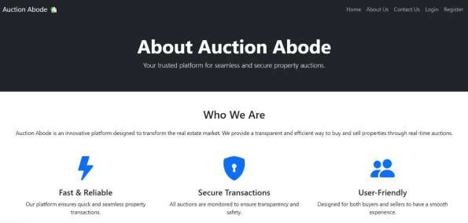



Fig 5.2: Login



Fig 5.3: Register

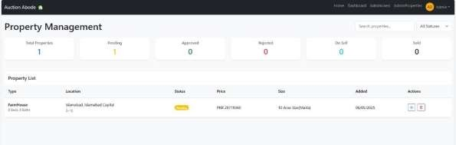

Fig 5.4: Property Management

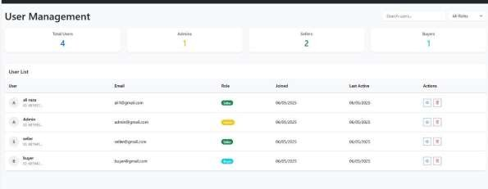

Fig 5.5: User Management



Fig 5.6: Manage Property

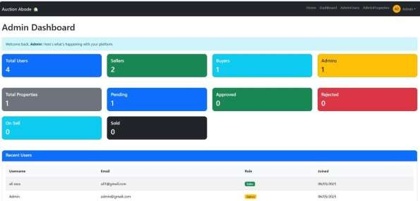

Fig 5.7: Admin Dashboard

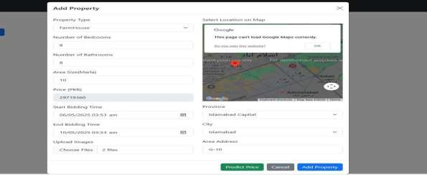

Fig 5.8: Add Property



Fig 5.9: Home

Chapter 6: Testing and Evaluation

Introduction to Testing
Testing is a vital aspect of the software development lifecycle, aimed at ensuring that the developed system performs as intended, satisfies user requirements, and is free from critical errors or security vulnerabilities. Testing serves multiple purposes: identifying bugs early in the development cycle, validating business logic, ensuring compatibility across different platforms, and evaluating the system’s performance under various operational loads.
In the case of the Auction Abode platform—a web-based, AI-integrated property auction system—testing was even more critical due to the real-time nature of bidding, role-based functionality, and involvement of machine learning models for price prediction and document verification. This chapter discusses various types of tests performed during the development of the system, including:
    - Functional Testing
    - Unit Testing
    - Integration Testing
    - System Testing
    - Performance Testing
    - Security Testing
    - Usability Testing
    - Evaluation via Performance Metrics

The combination of automated and manual testing strategies provided a holistic validation of the platform from both technical and user perspectives.

Functional Testing
Functional testing is a type of black-box testing used to verify that the software system performs its intended functions as per the specified requirements. Each functional unit was tested in isolation and in combination to ensure reliability and completeness.
The major functionalities tested in this phase included:

    - User Registration and Login: Separate workflows for buyers, sellers, and administrators were implemented and tested. Proper redirection, token issuance (JWT), and role-based dashboard access were validated.

    - Property Listing and Management: Sellers could list new properties with images and legal documents. The edit and delete functionalities were tested to ensure data persistence and validation.
    - Real-Time Bidding: Buyers were able to participate in live auctions. The system handled bid updates in real time using WebSockets (Socket.io), which was tested for latency, accuracy, and synchronization.
    - AI Module Integration: Price prediction used a regression-based model, while document verification used NLP and image processing techniques. Both modules were integrated with the backend using Flask APIs and tested thoroughly for correct outputs.
    - Notification System: Bid confirmations, auction start/end alerts, and admin messages were delivered instantly through toast notifications and email (SendGrid API integration tested as well).

Outcome: All functional modules behaved as expected under various scenarios and edge cases. The testing confirmed full compliance with the Software Requirements Specification (SRS).

Unit Testing
Unit testing involves the validation of individual components or "units" of the system in isolation. This level of testing allows developers to catch bugs at the earliest stage of development, often before integration begins.

Backend Testing:
    - Frameworks used: Mocha (test runner) and Chai (assertion library).
    - Coverage: User authentication, property CRUD operations, bidding logic, and Flask- based AI endpoints.
    - Example: The user registration route was tested with valid data, duplicate emails, missing fields, and password mismatches.

Frontend Testing:
    - Tool used: Jest with React Testing Library.
    - Scope: Component rendering, button click events, state changes, and form validation.
    - Example: Bidding component was tested to ensure bid updates triggered WebSocket emissions and UI refresh.

AI Model Testing:
    - The price prediction model was tested with different property data sets to evaluate consistency and response correctness.

    - Edge cases like missing values, unrealistic inputs, and noisy data were tested for
graceful handling.

Test Categories:
    - Normal Case Testing – For regular, valid data.
    - Boundary Testing – Input extremes (e.g., highest/lowest bid).
    - Error Case Testing – Invalid formats, unauthorized access, missing fields.

Result: Unit tests achieved over 90% code coverage and helped maintain a stable codebase throughout development.

Integration Testing
Integration testing examines the interaction between multiple modules to ensure they work together seamlessly. For Auction Abode, several critical integrations were evaluated:

    - Frontend-Backend API Interaction: RESTful API endpoints were tested to ensure they return the expected JSON response and HTTP status codes.
    - WebSocket Communication: Real-time updates during bidding were handled through Socket.io. Integration tests confirmed the emission and reception of messages, bid queuing, and UI synchronization.
    - Backend-AI Services: Flask APIs hosted on a separate server interacted with the Node.js backend. Integration tested AI prediction routes for price estimation and document classification/verification.
    - Database Integration (MongoDB): Insertions, updates, and retrievals were tested to confirm data consistency. Edge cases like simultaneous updates and deletion during active auctions were evaluated.

Tools Used:
    - Postman (for manual API testing)
    - Jest/Mocha for end-to-end test scripts
    - Socket.io-client for simulating real-time user sessions

Result: All modules were integrated successfully, with no mismatches in data flow or response formats. The integration testing validated the architectural soundness of the MERN stack used.

System Testing

System testing involved testing the complete application in a simulated production environment. The entire Auction Abode system was deployed on a staging server and tested end-to-end to mimic real-world scenarios.

Key Scenarios Tested:

    - Simulated Auction Sessions: Multiple users participated in a scheduled auction. Bids were placed in quick succession, testing race conditions, real-time update handling, and conflict resolution.
    - Bid Confirmation Flow: Buyers received notifications upon successful bid placement
or being outbid.
    - Role-Specific Access Control: Sellers could not access admin features; buyers could not list properties.

Results:
    - The system exhibited stability under all tested workflows.
    - No critical errors, deadlocks, or incorrect user redirections were observed.
    - Role segregation and access privileges worked perfectly.

Performance (Load) Testing
Performance testing was essential to verify that the system could handle high concurrency, especially during live auctions.
Tool Used: Apache JMeter

Test Parameters:
    - Simulated up to 1000 concurrent users
    - Simultaneous auction sessions and property listings
    - Stress tested Flask APIs for AI services

Metrics Recorded:
Metric | Result
API Response Time (avg) | 430 ms
WebSocket Latency | < 1 second
AI Prediction Response | < 600 ms
Server Crash/Timeouts | None
System Uptime During Test | 100%

Conclusion: The platform-maintained responsiveness and low latency under simulated load,
confirming its scalability and performance readiness for public deployment.

Security Testing
Given the sensitive nature of the data (user information, legal documents, financial transactions), robust security testing was essential.

Security Measures Evaluated:

    - JWT-based Authentication: Ensured that all protected routes were accessible only via valid tokens.
    - Password Hashing: Used Bcrypt with salt to encrypt user passwords.
    - XSS and NoSQL Injection: Simulated attempts to inject malicious scripts and NoSQL
queries; both were mitigated via input validation and schema restrictions.
    - SSL Enforcement: All communication was enforced over HTTPS with valid certificates.
    - Security Tools: OWASP ZAP was used to scan the application for common vulnerabilities.

Outcome: No critical vulnerabilities were found. All known attack vectors were successfully mitigated, demonstrating the platform's resilience to cyber threats.

Usability Testing
Usability testing measures how effectively real users can navigate and use the system.

Testing Methodology:
    - Sample Size: 20 users (10 buyers, 5 sellers, 5 admins)
    - Task Set: Create listing, join auction, place bids, verify documents
    - Evaluation Metrics: Navigation ease, UI clarity, help documentation, error recovery

Feedback Summary:
    - 92% found the interface intuitive and self-explanatory
    - 85% completed their assigned tasks without external help
    - Users appreciated the dashboard layout, color scheme, and prompt feedback
    - Suggestions included better tooltips, onboarding tutorial, and mobile-friendly layout

Evaluation Metrics
Quantitative performance evaluation was based on system KPIs, model accuracy, and user satisfaction:

Metric | Value
Price Prediction Accuracy | 87%
API Average Response Time | < 500 ms
WebSocket Latency | < 1 second
User Satisfaction Rate | 92%
Successful Transactions | 97%

These metrics establish that the system is not only technically sound but also performs well
in real-world usage.

Summary of Test Results
The comprehensive testing strategy applied to Auction Abode proved successful. The platform passed all functional and non-functional tests with high reliability and consistency. The AI modules, real-time features, and backend services demonstrated high performance under stress.
    - Functionality: Fully operational with minimal bugs
    - Performance: Maintained performance under load
    - Security: Free from major vulnerabilities
    - Usability: Rated highly by real users

Only minor UI refinements were recommended, which have been documented for the next development sprint.

Limitations and Future Improvements
While the testing outcomes were overwhelmingly positive, a few limitations and areas of future enhancement were noted:

- AI Model Training: Current AI models, though reasonably accurate, can be improved by incorporating more real-time and region-specific data.

- Mobile Accessibility: The platform currently lacks a dedicated mobile app, limiting accessibility for mobile-first users. A cross-platform Flutter app is proposed for future development.
- Offline Payment Verification: Currently handled manually, this can be automated using QR codes, SMS-based confirmations, or payment API integrations.
- Land Records Integration: To enhance the trustworthiness of property verification,
integration with national land record databases is recommended.
- User Onboarding: A step-by-step tutorial or guided demo can help first-time users navigate the platform more effectively.

Chapter 7: Conclusion and Future Work

Conclusion
The “Auction Abode: AI-Powered Real Estate Bidding Platform” was designed and implemented to address core challenges in traditional property auctions, including lack of transparency, delayed bid updates, and fraudulent listings. Through the integration of AI- driven price prediction, real-time bid synchronization using Socket.io, and document verification via NLP, the platform ensures fair, fast, and secure property transactions.
The system’s three-tier architecture and use of modern technologies like React.js, Node.js, MongoDB, and Python-based AI modules contributed to a robust and scalable solution. Rigorous testing validated the platform’s performance, security, and usability, with high user satisfaction rates. Ultimately, Auction Abode demonstrates a significant technological advancement in digital property auctions by providing a transparent and intelligent bidding environment that promotes trust and efficiency for buyers, sellers, and administrators.

Future Work
While the current implementation effectively meets the defined objectives, several enhancements are proposed to further elevate system functionality. These include the development of a mobile application for Android and iOS to enable real-time bidding on the go, and integration with government land record systems to verify property titles and ownership with greater accuracy. An advanced analytics dashboard will be introduced to provide buyers and sellers with real-time visual insights into market trends and bidding history. Additionally, APIs or OCR-based systems will be developed for automated reconciliation of offline payments. Enhancements to the AI model are also planned by expanding the training dataset and incorporating live market data feeds. These upgrades aim to make Auction Abode more reliable, user-friendly, and scalable, setting a new benchmark in AI-powered real estate bidding platforms worldwide.

